**23.01.2019**



**MIDDLE EAST TECHNICAL UNIVERSITY ELECTRICAL-ELECTRONICS ENGINEERING DEPARTMENT**

**EE463 POWER ELECTRONICS I**

**Fall 2018**

**HARDWARE PROJECT REPORT**

**Team Name: Smart Grid**

**Team Members: İven GÜZEL 2030831**

**Onur KÜLAHLIOĞLU**

**Ekin SAÇIN 2031300**

**To be submitted to: Ozan KEYSAN**

Table of Contents

1. INTRODUCTION 3

2. DESIGN DECISIONS 3

2.1. Topology Selection 3

2.2. Gate Driver 3

3. COMPUTER SIMULATIONS 3

4. COMPONENT SELECTION 3

5. IMPLEMENTATION STEPS 3

6. TEST RESULTS 3

7. CONCLUSION 3

APPENDIX A: Source Code of Arduino Gate Driver 3

APPENDIX B: TIPS for Next Year’s Students 3

REFERENCES 3

# INTRODUCTION

This report presents the details of EE463 Hardware Project. The aim of this project is to design and complete the setup of a controlled AC to DC motor drive. The teams must define a topology in order to make a proper design for feeding motor from three phase AC supply.

All requirements and results for selected topology is presented in this report. Selected components for chosen topology are listed. The simulation results and design schematic are provided Simulink, MATLAB. Finally, the test results of the demonstration are presented due to using equipment in laboratory.

# DESIGN DECISIONS

## Topology Selection

## Gate Driver

# COMPUTER SIMULATIONS

After choosing the topology of the driver, we started to determine the proper equipment by analyzing the simulation results. Voltage ripple, average output voltage, and current were adjusted by changing the parameters of the equipment. We measured the terminals of the DC link capacitor to determine the voltage ripple by changing the capacitor values and measure the terminals of the diode as output voltage. Also, we measured the armature current of the DC motor. We tried to adjust output voltage at 220 Volts which is the rated voltage of the machine. We used 150 V, rms as input voltage of the driver circuit.

In this part, some simulations were made by MATLAB Simulink for three different cases. We arranged the parameters of the equipment with respect to the datasheet of the equipment that we bought. In these cases, the duty cycle was changed and some important parameters were observed. The value of duty cycle was adjusted with the pulse generator. The circuit schematic of simulations is in Figure 3-1.

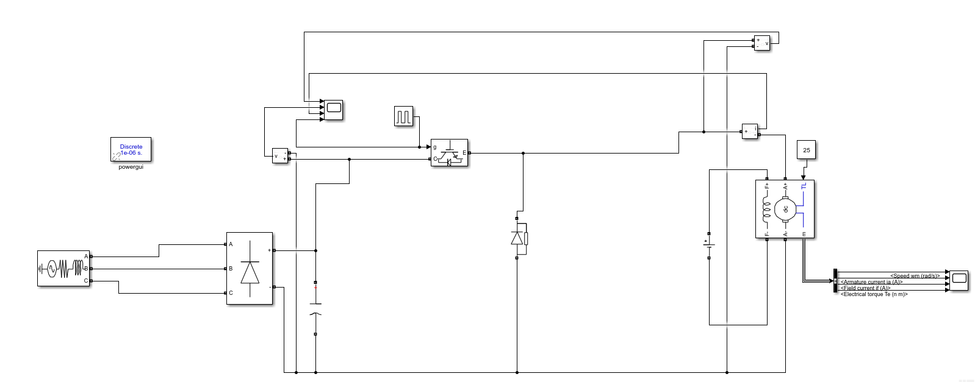

Figure 3.1- The circuit schematic of converter in Simulink

As an extreme case, when we adjust the duty cycle of the gate-input as 1, we observed the following results seen in the Figure-3.2, 3.3 and 3.4.

* PWM Duty Cycle = 1

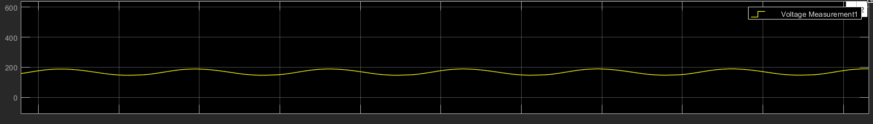

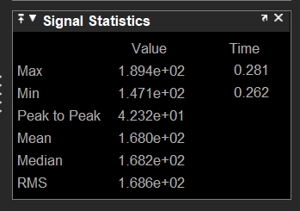

Figure 3.2- Diode Voltage

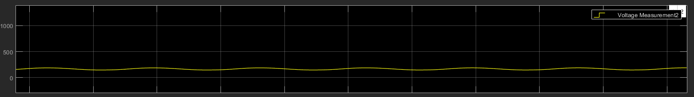

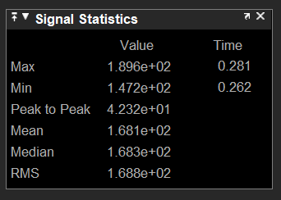

Figure 3.3- Voltage of DC link capacitor

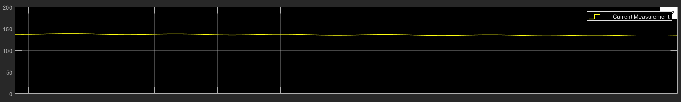

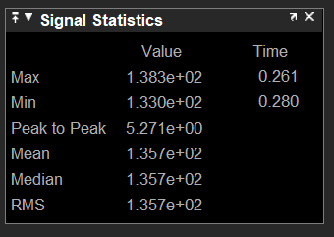

Figure 3.4- Motor current

To get more realistic results, we arranged the duty cycle of the gate-input as 0.5 and we observed the voltage of the DC link capacitor and diode as an input and output voltages as seen in the Figure-3.5 and 3.6. Besides, we obtained the armatüre current of the DC motor.

The simulations results for duty cycle = 0.95

|  |  |
| --- | --- |
| IGBT Voltage RMS | 3 |
| IGBT Current RMS | 5 |
| Diode Voltage RMS | -140 |
| Diode Current RMS | 0.9 |
| Capacitor Voltage RMS | 180 |
| 3 Phase Rectifier Voltage RMS | 180 |

* PWM Duty Cycle = 0.5

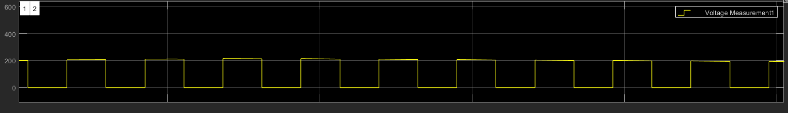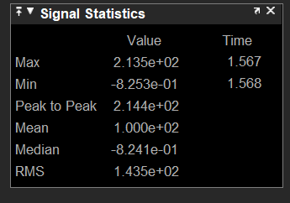

Figure 3.5- Diode Voltage

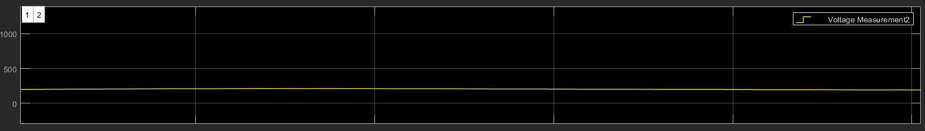

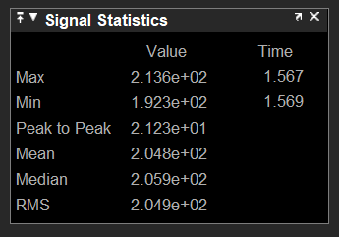

Figure 3.6- Voltage of DC link capacitor

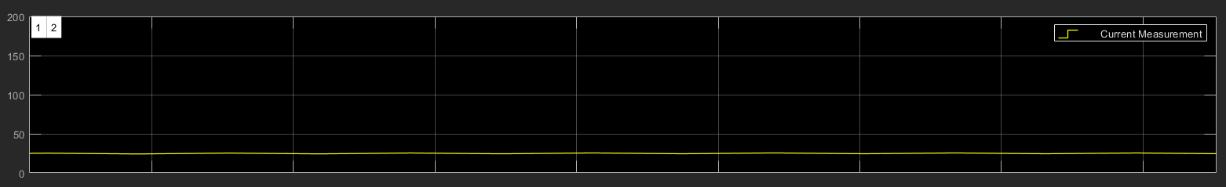

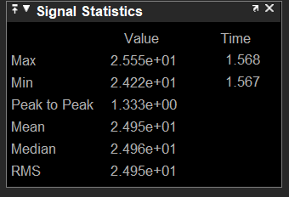

Figure 3.7- Motor current

As another extreme case, we changed the duty cycle of the gate-input as 0.2. Probably, it is not enough to rotate the machine, but we wanted to observe the characteristics of the circuit at this duty cycle. The simulation results can be seen in the Figure- 3.8, 3.9 and 3.10.

* PWM Duty Cycle = 0.2

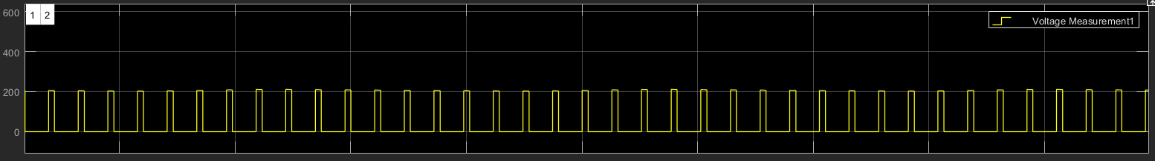

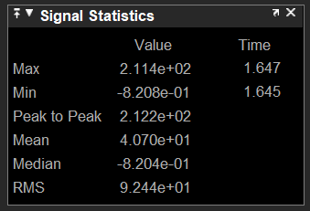

Figure 3.8- Diode Voltage

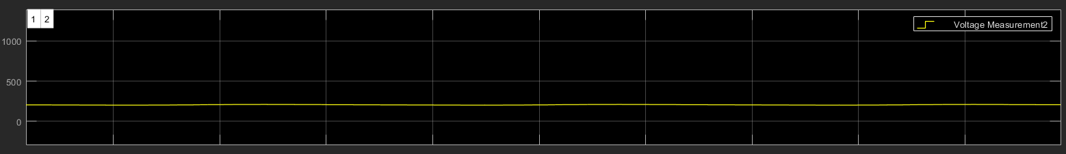

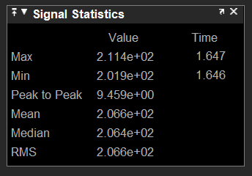

Figure 3.9- Voltage of DC link capacitor

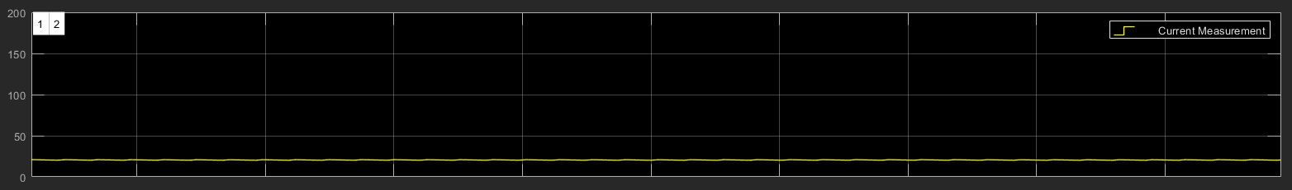

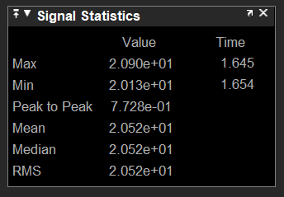

Figure 3.10- Motor current

# COMPONENT SELECTION

## 4.1 Cost Analysis

|  |  |
| --- | --- |
| MAIN COMPONENTS | COST(TL) |
| 3-Phase diode rectifier module | 60 |
| IGBT | 40 |
| Freewheeling diode | 20 |
| Capacitor(x3) | 3x20 |
| Arduino | 23 |
| Optocoupler | 15 |
| Heat Sink(x3) | 3x5 |
| Ventilator | 20 |
| Stripboard | 10 |
| Plastic box | 40 |

Other than these components, we have used ceramic capacitors, resistors, cables, connectors, thermal paste, sockets and battery.

# IMPLEMENTATION STEPS

# TEST RESULTS

We have tested all subparts after purchasing them to make sure that they are suitable for the project. Firstly, we have tested diode rectifier module and 540 µF DC link capacitor by using resistive load. As seen in the Figure-6.1, output voltage has almost no ripple thanks to the capacitor.

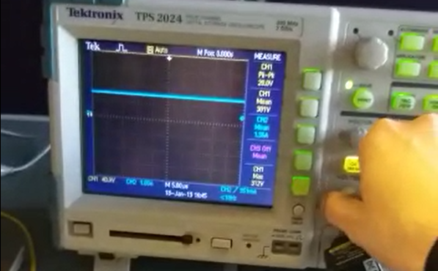

Figure-6.1: Output voltage of the diode rectifier module with DC link capacitor

We also looked at the gate signals of the IGBT generated by the Arduino with the help of an oscilloscope. Results for 2 different duty cycle is seen in the Figure-6.2.

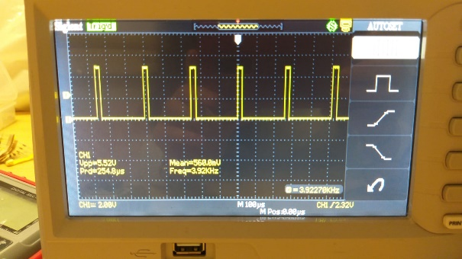 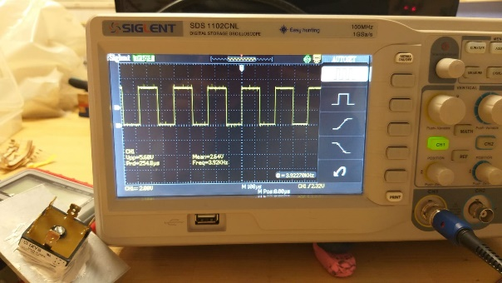

Figure-6.2: Output of the Arduino with 2 different duty cycle levels.

After tested the 2 subsystems mentioned above, we build the whole circuit and tested with resistive load and low input voltage. We observed overvoltage at the beginning of each cycle of the output voltage. This is dangerous for high power application. This could have burned our components, so we decided to use RC snubber to decrease the overvoltage. You can see the effect of the snubber in the Figure-6.3.

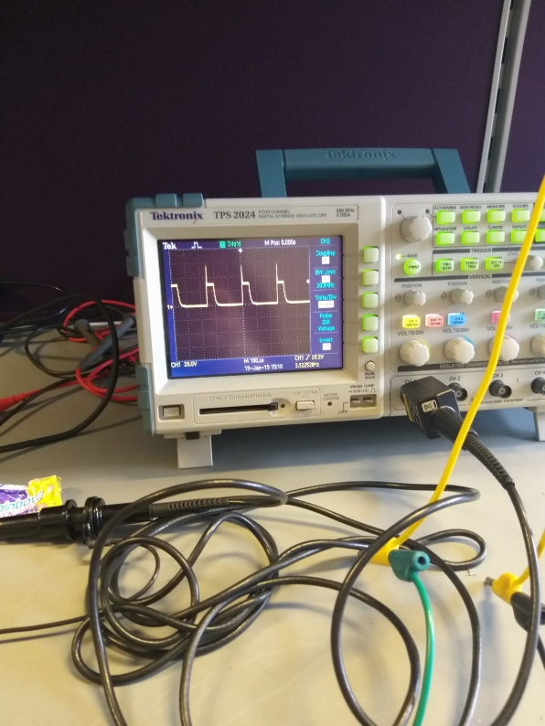 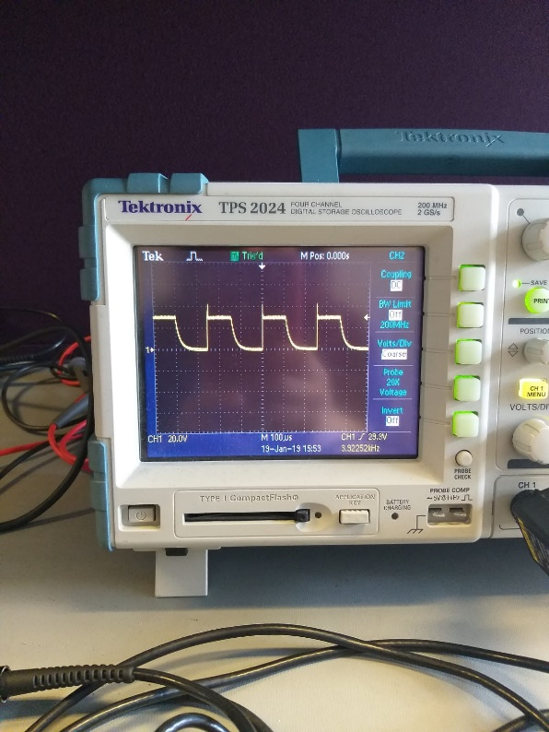

Figure-6.3: Output voltage without snubber (left side) and with snubber (right side).

Finally, we were ready to test our circuit with RL load. Test results were what we expected as seen in the Figure-6.4. We managed to control the output voltage of the load by changing the duty cycle of the gate voltage of the IGBT.

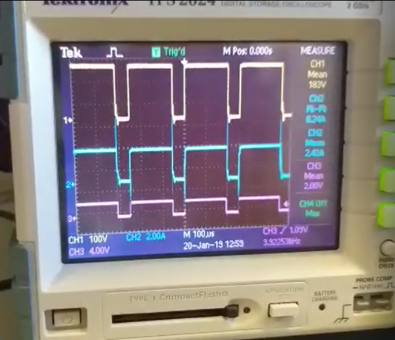 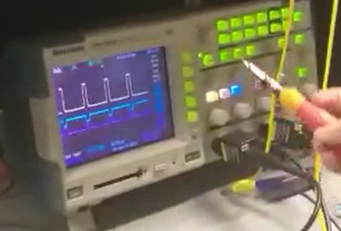

Figure-6.4: Output voltage and current with RL load with different duty cycles

All tested were successful at the power electronics laboratory, so we decided to test our design in the machinery laboratory with DC motor. Our driver was operating well until there were some problems with the DC motor. Results before the problem are seen in the Figure-6.5.

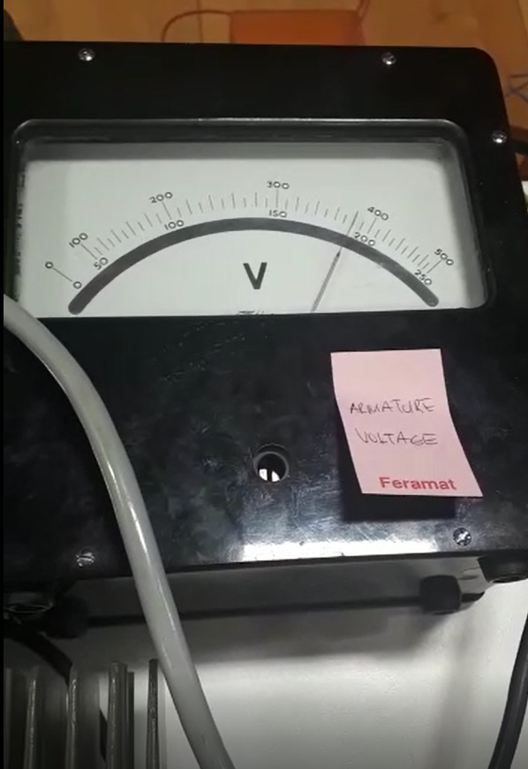 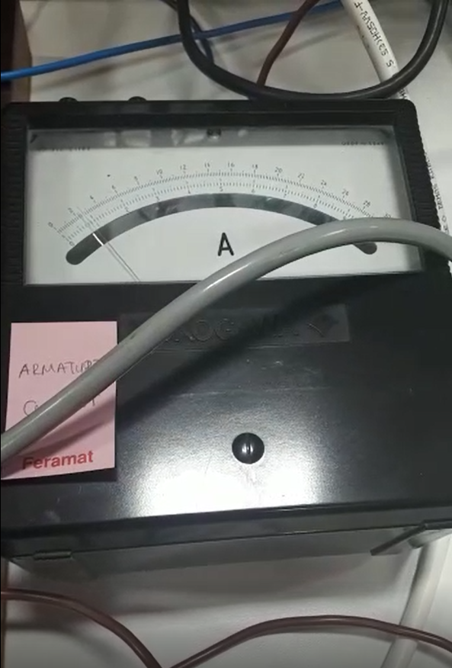

Figure-6.5: Input voltage and current of the DC motor.

We tried to arrange the output voltage of the driver at the rated voltage of the DC motor which is 220 Volts. Motor was drawn about 2.2 amperes at no load and 6 amperes at full-load. At the full-load, motor was drawn about 10 amperes on the demo day due to effect of series resistance at the load side. At no load, the temperature of the driver was around 30 degrees as seen in the figure-6.6, but at the full load, it was up to 70 degrees.

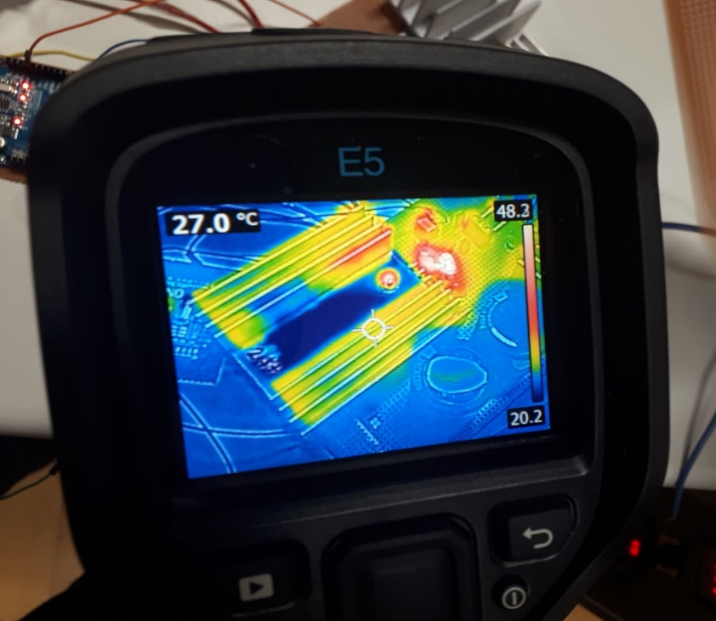

Figure-6.6: Input voltage and current of the DC motor

# CONCLUSION

# APPENDIX A: Source Code of Arduino Gate Driver

# APPENDIX B: Tips for Next Year’s Students

# REFERENCES